**Chapter 1 Background**

* 1. **Design Background**

Banks are indispensable in every region. They are the safest place for money to be deposited, and they are the places where the money flows most. The management of the banks is also very strict and can not allow any reliable mistakes to occur. This involves the banks High-tech applications, and high-tech can not be separated from the computer applications. So far, the computer has been widely used in the bank's financial management. The company is located in:

At present, human trust in banks is high, which increases the complexity and complexity of banking services. However, there are some simple services that users can complete themselves. The system is to achieve the business users can complete the management of their own, and the purpose of database management information. Therefore, the system can achieve the general user withdrawals, inquiries, change the password, transfer and other functions

* 1. **Design Analyse**

1.2.1 Login

Login system needs to retrieve all user information. The system design must ensure that the user's security, once logged in can be done after login function. Only enter the account number and password in the case can log in successfully. When you log in to retrieve all the logged-in user's information, make sure that you are logged in to enter the account and the password is entered correctly.

1.2.2 Search

System inquiries business, in the case of the log in before they can conduct this business. When querying for information, the information of the account in the file is directly retrieved according to the account, and the user's name and account number and the balance in the account are prompted.

1.2.3 Password modify

System password to modify the business, to log in the case can be carried out this business. Enter the original password, then enter the revised password, and then confirm the new password to complete the business. Here you need to modify user data and save it in a file. Direct access to information here, modify the data and then save it to a file.

1.2.4 Transfer

System of the transfer business, to log in the case can be carried out this business. To accurately enter each other's account and enter the amount of transfer, and determine the transfer can be successful. Here you need to modify and save the two user data. Complete this business, you can enter the other account to find and match, and then modify the value of the two nodes are the last to save

**Chapter 2 Design introduction and design plan**

**2.1 Design Introduction**

According to the life of ATM business requirements and customer needs analysis, the system needs to achieve registration, login, deposit and withdrawal, query, transfer, change the password and other functions. The user can register a bank account with the identity account through the registration service and log in to the ATM system through the bank account after registration so as to save, withdraw money, check the account information and change the password in the system.

**2.2 Requirement Analyse**

With the development of society, banks play an important role in people's daily life. ATM machines bring convenience to people's daily life, it appears in various street corners. ATM database system makes cash machine high-speed and efficient work, less prone to data loss, statistical errors, make ATM machine more safe and convenient. The company is located in:

This database system includes the functions of opening an account, depositing, withdrawing money, transferring money, inquiring about, changing a secret, etc., Among them has used the database stored procedure knowledge

**2.3 Model Design**

2.3.1 Register Model

Brief introduction: To use this system must first register an account, save to the file. The company is located in:

Flow chart is as follows:

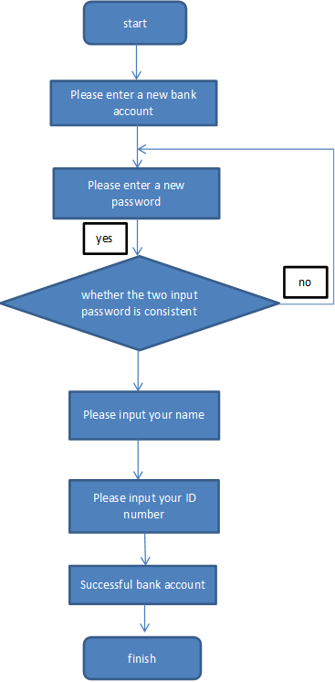

2.3.2 Search Model

Brief introduction: Query module can be achieved is to select the query, access to the array information directly displays the user's account, balance, name and other information.

Flow chart is as follows:

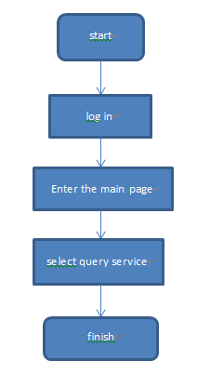

2.3.3 Withdraw Model

Brief introduction: Withdrawal module can achieve the user's withdrawal, at the same time to retrieve the information in the file, and the withdrawal amount for the user in the original balance of the correct changes.

Flow chart is as follows:

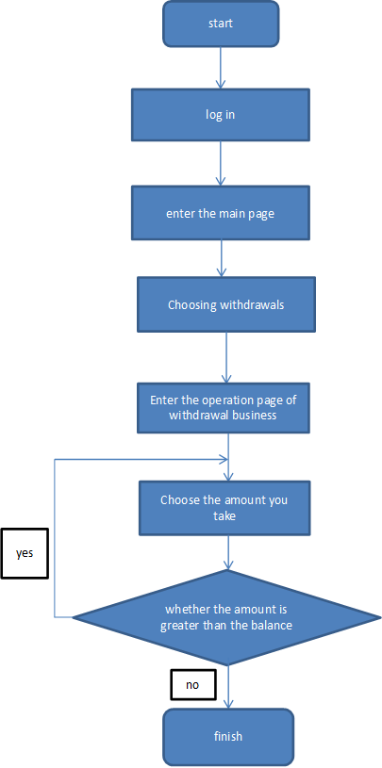

2.3.4 Deposit Model

Brief introduction: The deposit module can realize the withdrawal of the user, and retrieve the information in the file at the same time, and correct the amount of the user deposit on the original balance.

Flow chart is as follows:

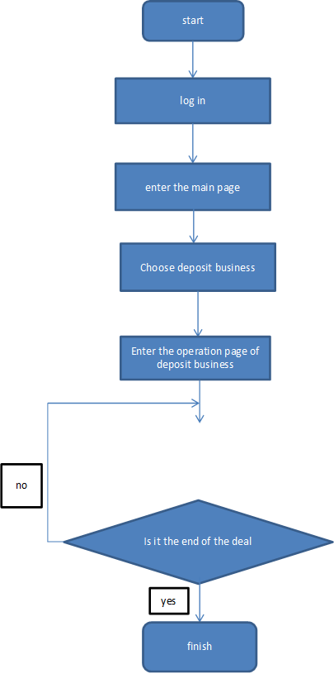

2.3.5 Change Password Model

Brief introduction: To change the password module to achieve the user's password changes, enter the original password can enter a new password, again after the confirmation can be modified successfully.

Flow chart is as follows:

